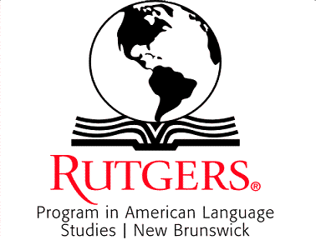
Day/Time | Monday  07/05 | Tuesday  07/06 | Wednesday  07/07 | Thursday  07/08 | Friday  07/09
9:00 – 10:00 |  | Welcome & Orientation | Language instruction | Language instruction | Language instruction
10:20 – 11:50 |  | Placement test (all students) | Personalized Lab work | Personalized Lab work | Personalized Lab work
*12:00 – 1:00 |  | Lunch | Lunch | Lunch | Lunch
1:00 – 2:00 |  | Language instruction | Language instruction | Language instruction | SEMINAR
2:20 – 3:20 |  | Focused study  ( small groups) | Field Trip to | Focused study  ( small groups) | HOW TO APPLY FOR
3:40 – 4: 40 | Arrival Jilin Group | Invited Lecture  (Related to English Language Usage) | Zimmerli Museum | Invited Lecture  (Related to English Language Usage) | GRADUATE SCHOOL
Program In American Language Studies
Rutgers, The State University of New Jersey
Summer Course Schedule – July 2010

Day/Time | Monday  07/12 | Tuesday  07/13 | Wednesday  07/14 | Thursday  07/15 | Friday  07/16
9:00 – 10:00 | Language instruction | Language instruction | Language instruction | Language instruction | Language instruction
10:20 – 11:50 | Personalized Lab work | Personalized Lab work | Personalized Lab work | Personalized Lab work | Personalized Lab work
*12:00 – 1:00 | Lunch | Lunch | Lunch | Lunch | Lunch
1:00 – 2:00 | Language instruction | Language instruction | Language instruction | Language instruction
2:20 – 3:20 | Focused study  ( small groups) | Focused study  ( small groups) | Field Trip  (local) | Focused study  ( small groups)
3:40 – 4: 40 | Cross-cultural Workshop | Invited Lecture  (Related to English Language Usage) |  | Cross-cultural Workshop
Program In American Language Studies
Rutgers, The State University of New Jersey
Summer Course Schedule – July 2010

Program In American Language Studies
Rutgers, The State University of New Jersey
Summer Course Schedule – July 2010
Day/Time | Monday  07/19 | Tuesday  07/20
9:00 – 10:00 | Language Instruction | Departure Jilin Group
10:20 – 11:50 | Personalized Lab work
*12:00 – 1:00 | Lunch
1:00 – 2:00 | Language Instruction
2:20 – 3:20 | Valedictory Dinner &
4340 – 4: 40 | Award of Certificates

Important information about PALS Summer English language Program
Objective - Instruction will be provided in all four skills (Reading, Writing, Listening & speaking), and main focus will be to develop clarity and confidence in oral communication.
Language Instruction – means a regular class with PALS faculty for a specific level and a specific discipline
Focused study – means students will work in small groups (no more than 5) with an ESL expert on an identified area of speech, grammar or language construction
Personalized Lab. Work – means individual students will work in the language lab with a faculty member to overcome their personal English speech problems using personalized materials. Students will create personal audio diaries.
Cross-cultural Workshop – students will work with an expert to learn about American culture and other cultures. The workshops will be interactive and the students will participate in different activities and games. Students will be encouraged to talk about their culture.
Invited Lecture - Expert faculty will be invited to speak on important aspects of English language structure and usage. Focus will be to provide information that will be of direct use to the students. The invited lectures will be level specific.
Field Trip – means that the students will be taken to visit the local museum and Rutgers Botanical Park. Each trip will be preceded and followed up with associated language work.

